Module 6
Coaching Performance
Delegate Workbook

Module 6
Coaching Performance

Module Objectives

On completion, you will:

- Understand the difference between coaching and other management tools
- Recognise the skills of a good coach
- Be able to utilise a basic coaching framework to coach team members

Topics covered:

- Essential coaching skills
- The coaching continuum
- The GROW model
- Using coaching to improve performance
- Practical application to build confidence

Module 6
Coaching Performance

- Coaching

1.1 The benefits of coaching

John Whitmore highlighted some of the following benefits in his book, Coaching for Performance:

1.2 What is coaching?

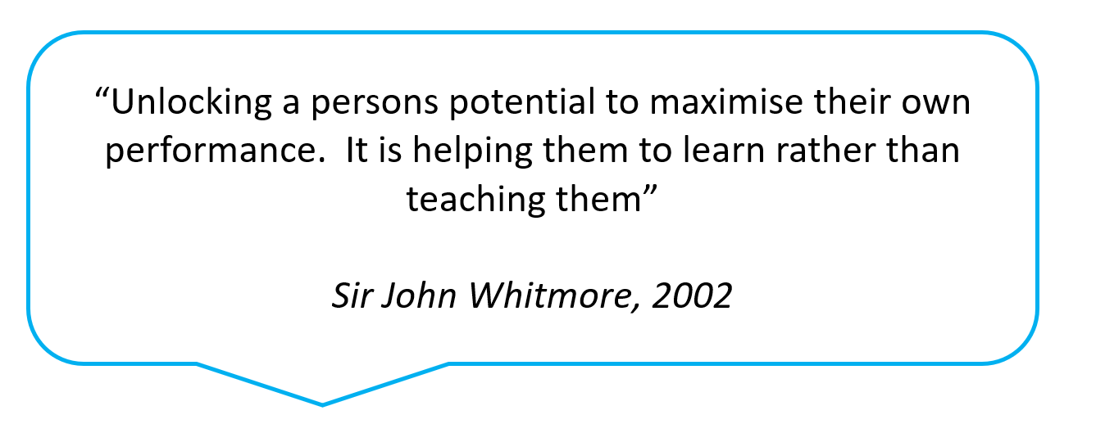

1.3 When to use coaching

Coaching is another tool available to Managers and is not appropriate for all situations. The skill lies in being adaptable to situations and recognising where it would yield most benefit, not just simply taking action which would be “quickest” at the time.

When deciding whether to coach, consideration can be given to the following three areas:

1.4 Coaching style

Watch the clip and make your own notes below:

- Skills of an effective coach

2.1 Effective conversations

Watch the clip where the presenter talks about how to have effective conversations.

Enter below what you believe are the skills required to be an effective coach:

2.2 Trust and rapport

In a coaching activity, we are trying to get individuals to the highest levels of rapport so that they feel they can share views, opinions, and feelings without fear of being judged. Rapport is a key factor in building trust. To build rapport there are three key elements you need to demonstrate – record these below:

Empathy is:

Sympathy is:

2.3 Skills of an effective coach

List below the skills required to be an effective coach:

Skills of an Effective Coach

Your notes:

3.0 Preparing for coaching

3.1 Contracting

It is vitally important to agree some ways of working with the person you are coaching at the outset. This may be the first time that they have experienced coaching and they may be unsure about what coaching is and how the process works, therefore you need to define your role with the coachee and agree some clear boundaries.

Your notes:

Think about your role as a coach in your organisation. What are the key important points you need to make sure are really clear before you started to work with someone as their coach? Make a note of these below:

3.2 The role of a coach

Creating the right environment

Motivating

Offering feedback/constructive challenge:

Holding to account:

3.3 The GROW model

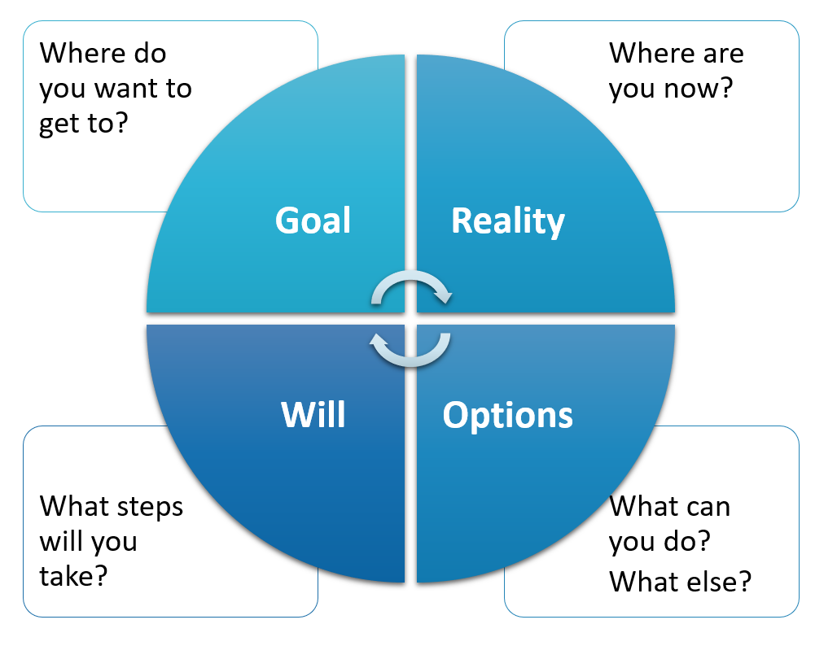

There are many different coaching models, however one which is widely used is the GROW model. It focuses on objectivity and concrete action, so it works best for getting practical things done.

The model offers four distinct headings to help with structuring a coaching conversation. These headings are aimed towards guiding the coachee through this process in order to reach an outcome.

Goal
Their aspirations
The first step is agreeing a goal with the coachee. The goal is the objective the person wants to reach. Sometimes this may be achieved by the end of the conversation, although often it may be worked on over a series of sessions. If this is vague, you may find you have a hard time with the rest of the steps, so it is worth being clear before progressing and making sure goals are specific.

Whilst the individual may have a longer-term goal, such as improving performance over a longer period of time, it should also identify the short-term goal, such as the goal for the session. This will allow you to keep the conversation on track and check that the individual feels this has been achieved at the end of your time.

Your notes:

Reality
Their current situation and beliefs
At this point you are attempting to establish some concrete facts about what is happening right now. In a performance situation this may involve current performance data or recent history. You may get the person’s subjective opinion, therefore it important to ask the right questions to allow you to reach an objective starting point for any desired change. Your role here is to stimulate self-evaluation and identify any obstacles which may have been holding them back. Often, this phase of the model reveals underlying fears and convictions that can be worked on during or in between coaching sessions.

Options
The possibilities and resources open to them
This stage is the process of encouraging the individual to think creatively and produce several potential solutions, not just one “right” idea. At this point the coach’s role is to allow the individual sufficient thinking time and encourage more creative thinking without censure or conditionality. It may also involve challenging any perceived barriers which may creep in to ensure these do not impact potential options. The ideas should come from the individual and coach is key here in encouraging them to expand their boundaries.

Will
The actions they want to take
Finally, the last stage involves helping the individual to turn their ideas into positive concrete steps they will take to make this happen. In doing this it is also advisable to check that this will give them the solution they set out to achieve. Make sure these also follow the SMART structure. It is also worth evaluating their level of buy-in on a scale of 1-10. For anything less than an 8, troubleshoot obstacles or encourage further thinking to increase the probability of a successful outcome.

Your notes:

3.4 Developing questions

Using the GROW model, prepare some questions you could use during a coaching session

- These should cover each stage of the model (e.g., Goal, Reality, Options, Will)
- Please aim to have at least two questions per stage.

Capture these below and bring these along for use within your workshop.

GOAL
REALITY
OPTIONS
WILL

