Module 7
Problem Solving
Delegate Workbook

Module 7
Problem Solving

Module Objectives

On completion, you will understand:

- What VUCA means and how it impacts your workplace
- Divergent thinking and how it differs to convergent thinking
- How to apply creative thinking techniques to aid problem solving
- Different thinking styles and how to maximise your own effectiveness
- How to creatively explore solutions from different perspectives
- How to set yourself a positively focused well-formed outcome

Topics covered:

- The VUCA world
- Divergent and convergent thinking
- Creative problem-solving techniques and models
- The 6 thinking hats
- Well-formed outcomes

Module 7
Problem Solving

- The VUCA world

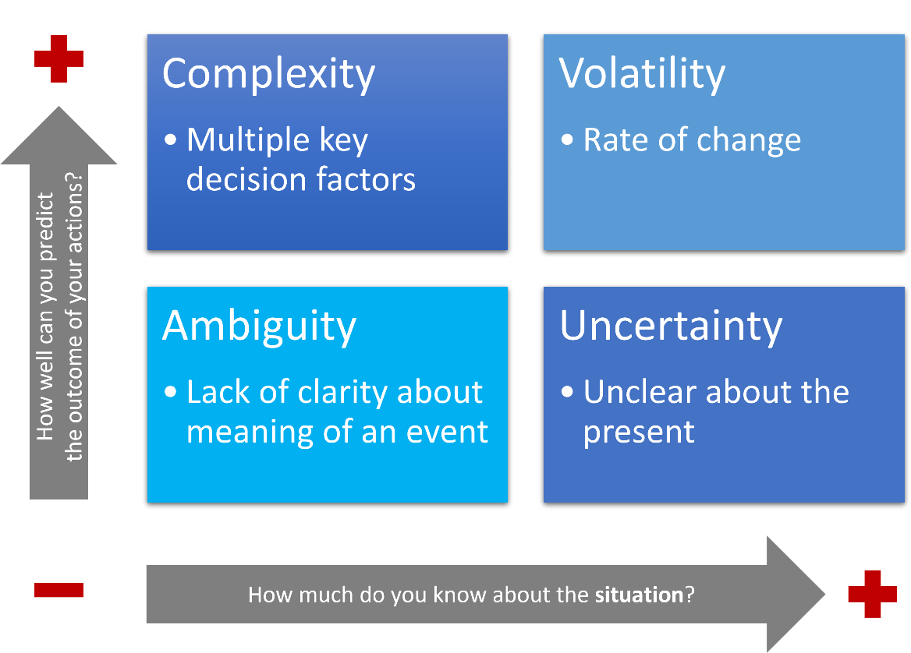
1.1 What is VUCA?
Make your own notes on the key points

Volatility
Uncertainty
Complexity
Ambiguity

To thrive in a VUCA world we need to develop our curiosity, expand our growth mindset (as discussed in Module 2) and ask open-ended questions to stimulate debate, invite differing views and fuel the imagination (see Module 4). If we listen to the answers with curiosity, we can develop a creative and agile edge to our problem-solving.

Questions to consider and bring to your workshop:

How do you recognise the above 4 VUCA areas in your world at work?

How much do they impact your capacity to solve problems?

What types of problems do you need to solve at work?

2.0 Divergent and convergent thinking

2.1 Applying creative thinking to problem-solving

Watch the short clip and make your own notes:

2.2 Divergent and convergent thinking

Divergent thinking is:

Convergent thinking is:

Questions to consider - bring your responses to your workshop:

Where do your personal strengths lie when you consider the two different thinking styles?

What would you like to develop to maximise your effectiveness?

Watch the short video and make your own notes:

3.0 Creative problem solving

3.1 Creative problem-solving techniques

Go for a walk
Creativity of constraints
Brainstorming
Preserving ambiguity
The hypothetical question
Mind mapping/
lateral thinking
Reframing
Envisaging something new
Role-play

3.2 Creative problem-solving model

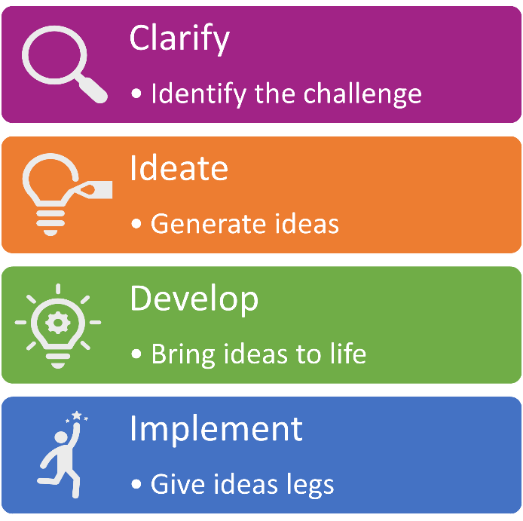

Clarify:

Ideate:

Develop:

Implement:

3.3 6 thinking hats

Blue hat
Green hat
Yellow hat
White hat
Red hat
Black hat

Questions to consider - bring your responses to your workshop:

Which of the hats do you prefer and most naturally put on?

Which of the hats are you least likely to wear?

What about other members of your team?

4.0 Well-formed outcomes

4.1 Outcome thinking

Why use a well-formed outcome?

What is a well-formed outcome?

4.2 Well-formed outcomes – PECSAW

Positive
Evidence
Context
Self-achievable
Advantages / Disadvantages
Worthwhile

4.3 Well-formed outcomes – alternative models

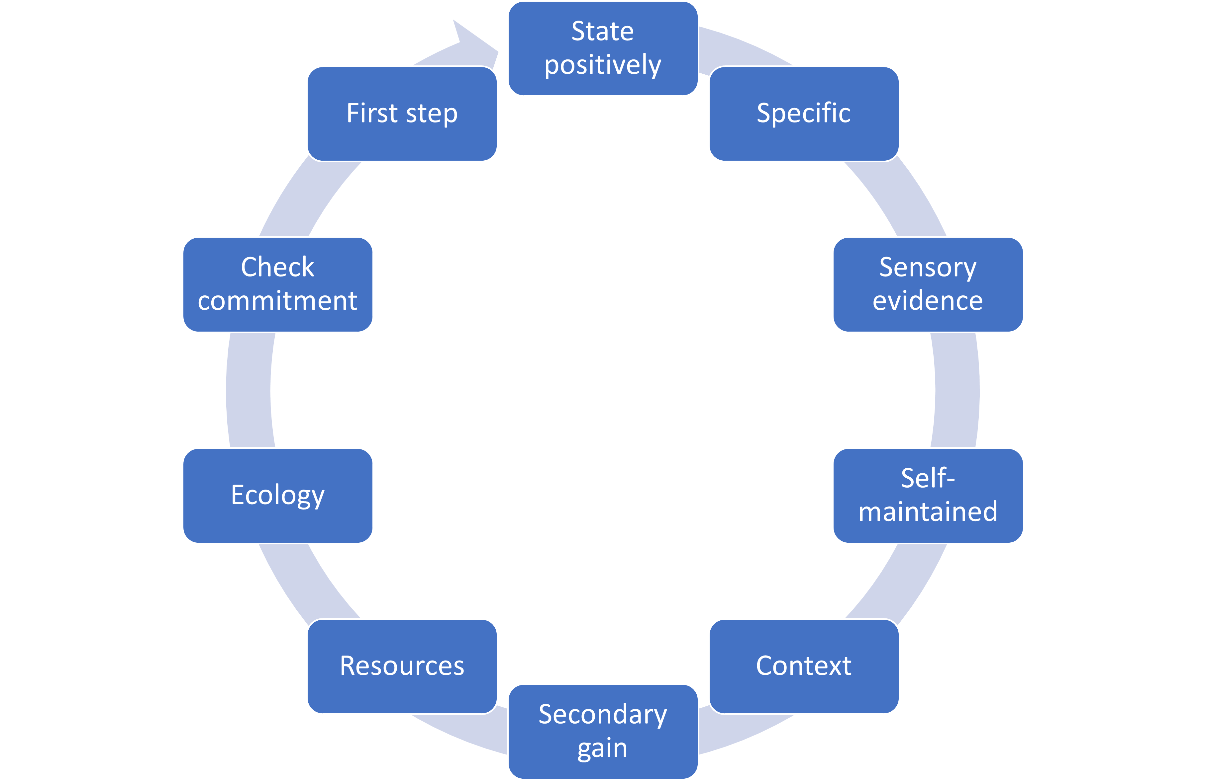

Your notes:

Here is an additional simplified model you could also utilise:

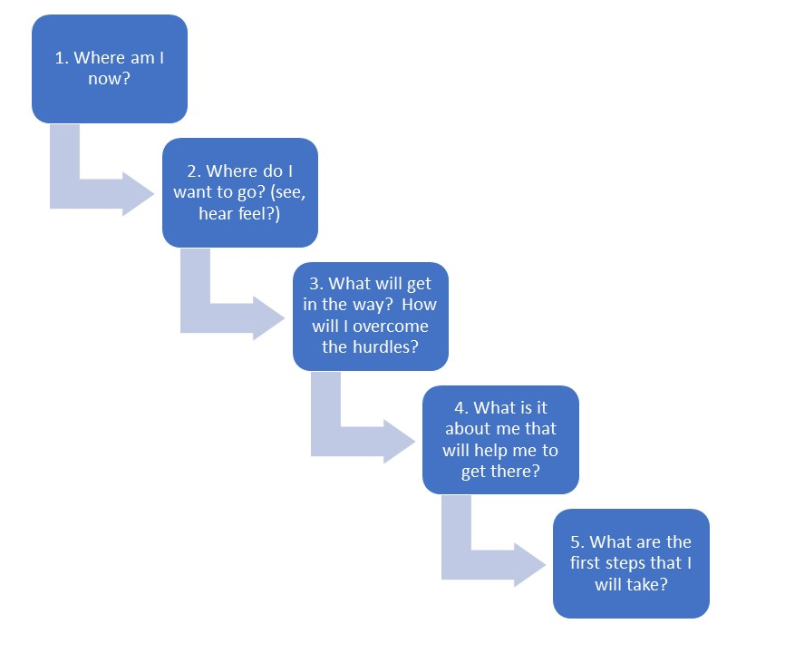
Your notes:

Now that you have a couple of models to choose from. You will probably find that one resonates more than the others.

- Think of an outcome that you would really like to achieve in order to continue the learning from your management development programme and make positive changes going forwards.
- Select one of the models you would like to try out to ensure your outcome is 'well-formed', then work through the relevant stages.

Bring this to discuss in your workshop.

