Module 4
Challenging Conversations
Delegate Workbook

Module 4
Challenging Conversations

Module Objectives

On completion, you will understand:

- Be able to undertake difficult conversations confidently and assertively
- Understand how to conduct a two-way conversation
- Identify causes of conflict at work
- Understand how to recognise and resolve conflict
- Know how to promote a collaborative atmosphere

Topics covered:

- Emotional state – self and others
- Causes of conflict
- Stages of conflict
- Thomas Kilmann conflict resolution model
- Preparing for challenging discussions
- Key skills e.g., questioning, listening and assertiveness

Module 4
Challenging Conversations

- Emotional state

1.1 Challenging conversations

Take some time to reflect now on any recent challenging conversations you have had.

- Do any of the points online resonate?
- Are there any patterns?

Your notes:

1.1 Different communication styles

Passive | Notes:
Typical behaviour:
- Apologising and feeling of imposing when you ask for what you want
- Avoiding any confrontation and giving in
- Finding it difficult to say no
- Yielding to someone else’s preferences and discounting own needs and wants
- Opting out
- Feeling like a victim
- Finding it difficult to take responsibility or decisions
- Blaming others for events
- Refusing compliments
Aggressive
Typical behaviour:
- Frightening, threatening, loud and hostile
- Willing to achieve goals at the expense of others
- Out to “win”
- Demanding and abrasive
- Being belligerent, explosive, or unpredictable
- Intimidating and bullying
Passive aggressive
Typical behaviour:
- Being manipulative using sarcasm
- Using body language to subtly put down others
- Using sulky and cunning behaviour
- Being two faced and gossiping
- Using artificial tears
- Generally manipulating others by using their blind spots or weaknesses
Assertive
Typical behaviour:
- Achieving goals without hurting others
- Protecting your own rights and respecting those of others
- Being appropriately socially and emotionally expressive
- Making your own choices and taking responsibility for them
- Asking directly for your needs to be met
- Accepting compliments

2.0 Skills

2.1 Levels of Listening

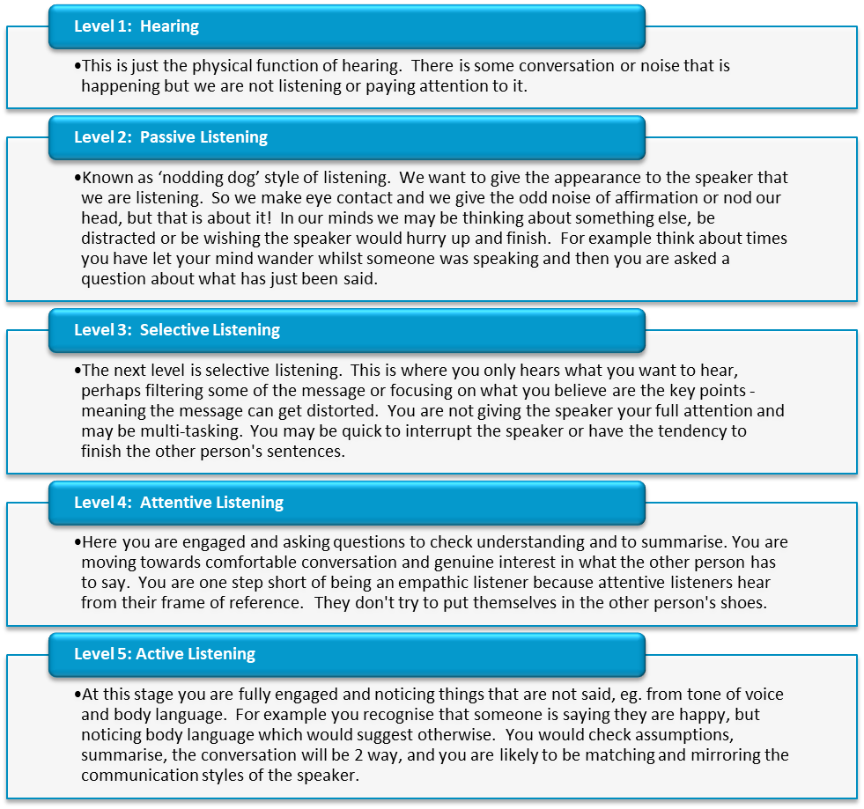

Your notes:

2.2 Types of questions

Effective questions include: | Examples:
Ineffective questions include: | Examples:

Your notes:

3.0 Conflict

3.1 Causes of conflict

Conflict can be caused by a wide range of things – a few of which are listed below. To successfully manage conflict, it is important to understand the root cause of the problem rather than just what may be seen at surface level.

Your notes:

3.2 Stages of Conflict

There are five main stages of conflict development:

Underlying conflict

Developing conflict

Conflict stalemate

Resolving conflict

Reconciliation

3.3 Managing Conflict

When conflict arises, a person’s behaviour can be described along two basic dimensions – assertiveness and cooperativeness. The Thomas-Kilmann Conflict Mode Instrument defines five specific methods of dealing with conflict as outlined below:

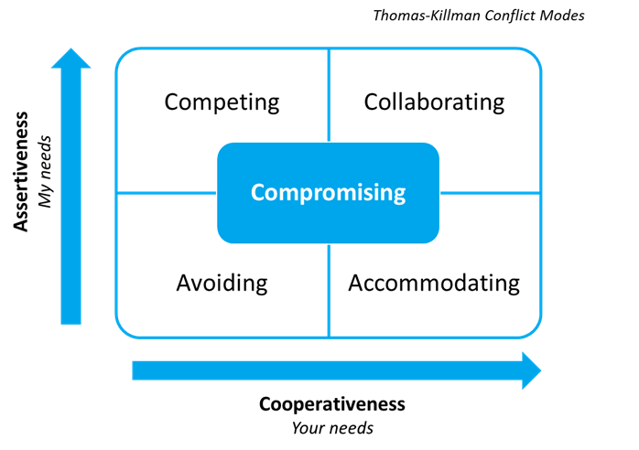

Competing

Accommodating

Avoiding

Collaborating

Compromising

Considering the above styles, answer the following questions and bring your responses along to your workshop:

Which of these conflict styles do you recognise in yourself at work?

Which particular situations and people cause, or could cause conflict for you?

