Managing Performance
Delegate Workbook

Managing Performance

Module Aim

- Understand how to plan and allocate work effectively
- Be able to monitor a team’s performance against the plan
- Know how to identify and utilise motivators
- Have a framework to deliver feedback constructively
- Know how to recognise and tackle underperformance constructively
- Be able to set appropriate challenge for high performing employees

Module Objectives

On completion, you will understand:

- Organisation objectives and how they link
- The importance of robust objectives and accountability
- Motivation theory
- Methods for monitoring and improving performance
- Capability and commitment
- Feedback essentials

“Even with well-designed processes, the behavioural practices of groups and individuals can make the difference between merely adequate results and outstanding results. In the worst case, poor practices can destroy good process.”

Tosti, D. (2003) Organizational alignment

Managing Performance

  - Organisation Objectives

  - Tosti and Jackson’s Alignment Model

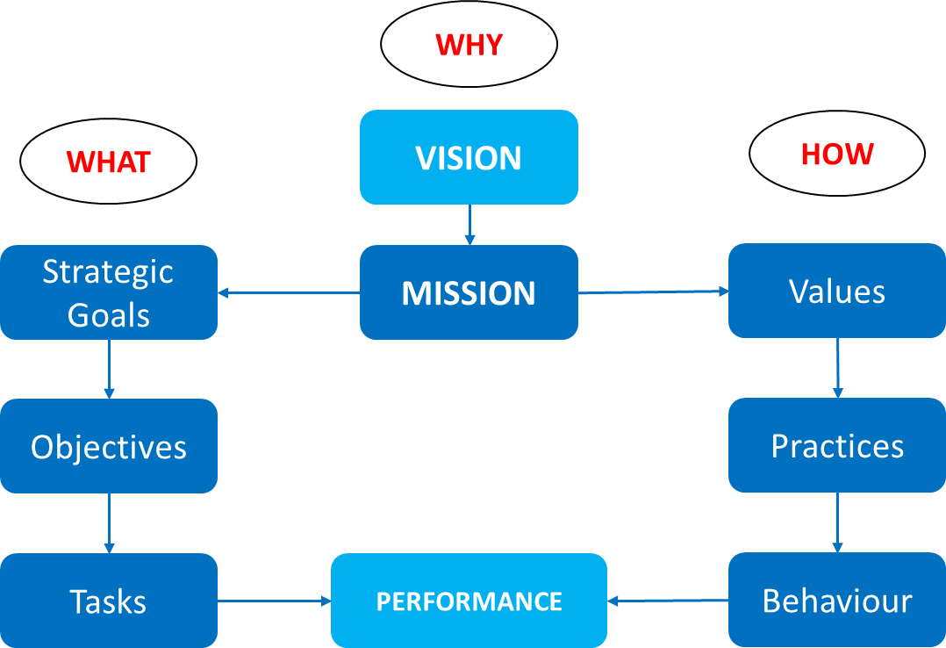

Your notes:

Consider your organisation in relation to the model. Are you aware of any gaps?

What is/would be the impact of uncertainty on yourself and your teams?

  - The objective thread

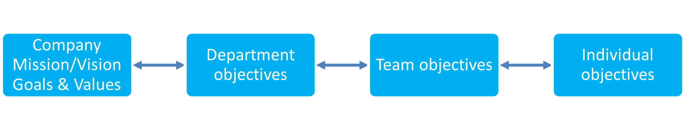
All objectives set across the organisation should follow a logical progression which clearly links the daily, weekly and monthly activities of each individual to the achievement of the highest strategic goals and company vision. As a manager, it is important to make sure the activities within your control are related to the plans in place.

We can then use this to analyse the things we are doing or are asked to do, to judge their relevance, e.g.;

- Why am I doing this? What is the purpose of this activity?
- Which of my goals/objectives does it add to? When my activities are reviewed against my goals, will this have value?
- Why will I succeed? Am I spending time on a doomed project that distracts me from other tasks?
- What would happen if I chose not to do it? If this task didn’t happen, would there be major implications or would no one care?

Summarising the answers to these questions may indicate that the activities undertaken either are, or are not, efficient and effective

Think about your own organisation and objectives and how they link.

- What is your organisation’s objective?
- How do your departmental objectives contribute toward that?
- How do your individual objectives contribute towards that?

- Performance Management

  - The meaning of performance management

Describe what performance management means to you?

What are the three main components of performance management?

  - Levels of performance management

Your notes:

  - ABC of performance management

Consider your work environment:

- Do employees know what is expected?
- What are your antecedents?
- What consequences are used?

Your Notes:

Antecedents get us going – consequences keep us going
  - Types of consequences:

The four consequences are:

Type | Description

Skinners Reinforcement Theory
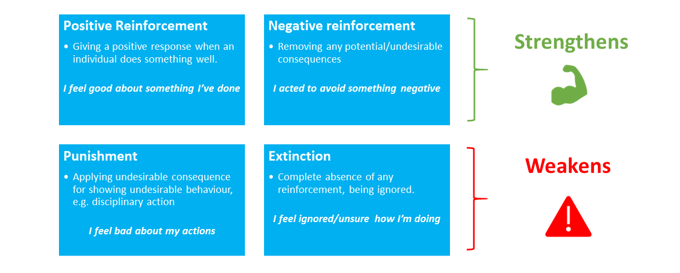

Things to remember about Skinners Reinforcement Theory

  - Working with consequences

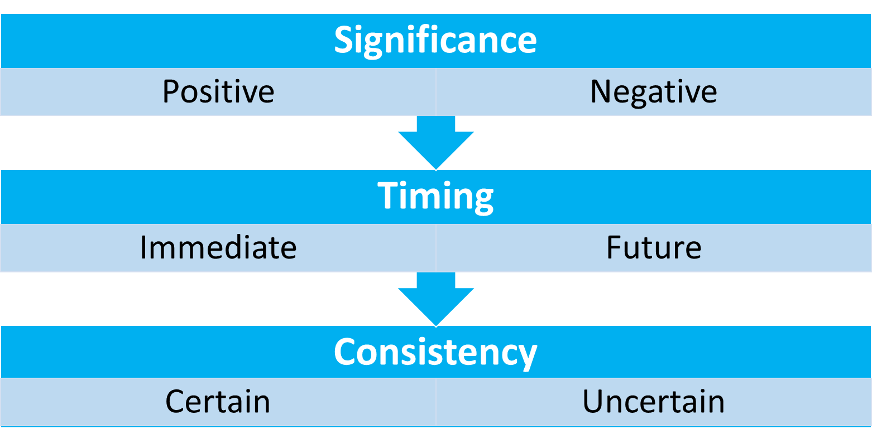

The most powerful consequences are

Your Notes:

  - Behaviour Cycle

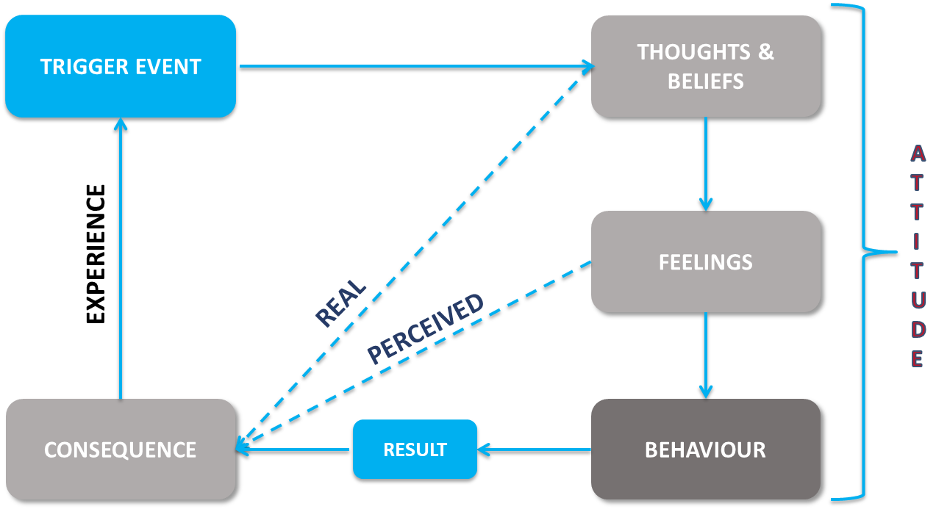

Your Notes:

- Measuring Performance

  - Measuring Performance

When monitoring performance there are two key areas of focus:

- Behaviour usually measured using competencies.
- Output usually measured by objectives

Organisations have many different systems and processes for monitoring activities, which are suited to the tasks, culture and environment of the organisation. To be effective, monitoring systems must satisfy the following three basic rules;

Your Notes:

  - Setting objectives

  - SMART

A commonly used framework for setting goals is to follow the SMART acronym. It provides a simple framework against which you can quickly check whether your goals are robust by checking the content of your objective against each of the following five components.

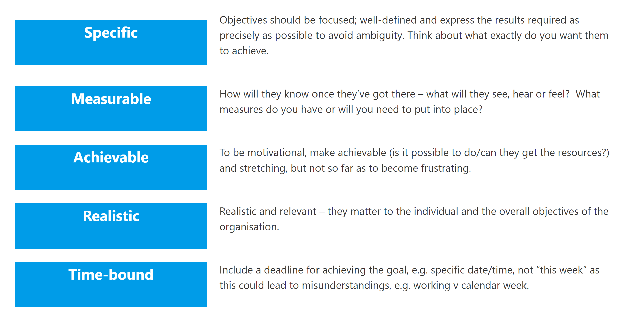

Practice activity:

- Pick 3 objectives currently used for the team you manage (In the event you are not managing a team, think of some you may have set with colleagues or for yourself).
- Review these using the SMART structure above and see if you are able to make these even SMART'er!
- Reflect on how goals are currently set for your team - what works/what doesn't?

Top tip:
When setting objectives, start with a verb, eg. “identify” “sell” “record” then add specifically what needs to be done and the conditions for doing it. For example, “sell 12 insurance products by 5.00pm on Friday 1 June 2017”. This gives your employees a concrete goal.

  - The Deming Wheel

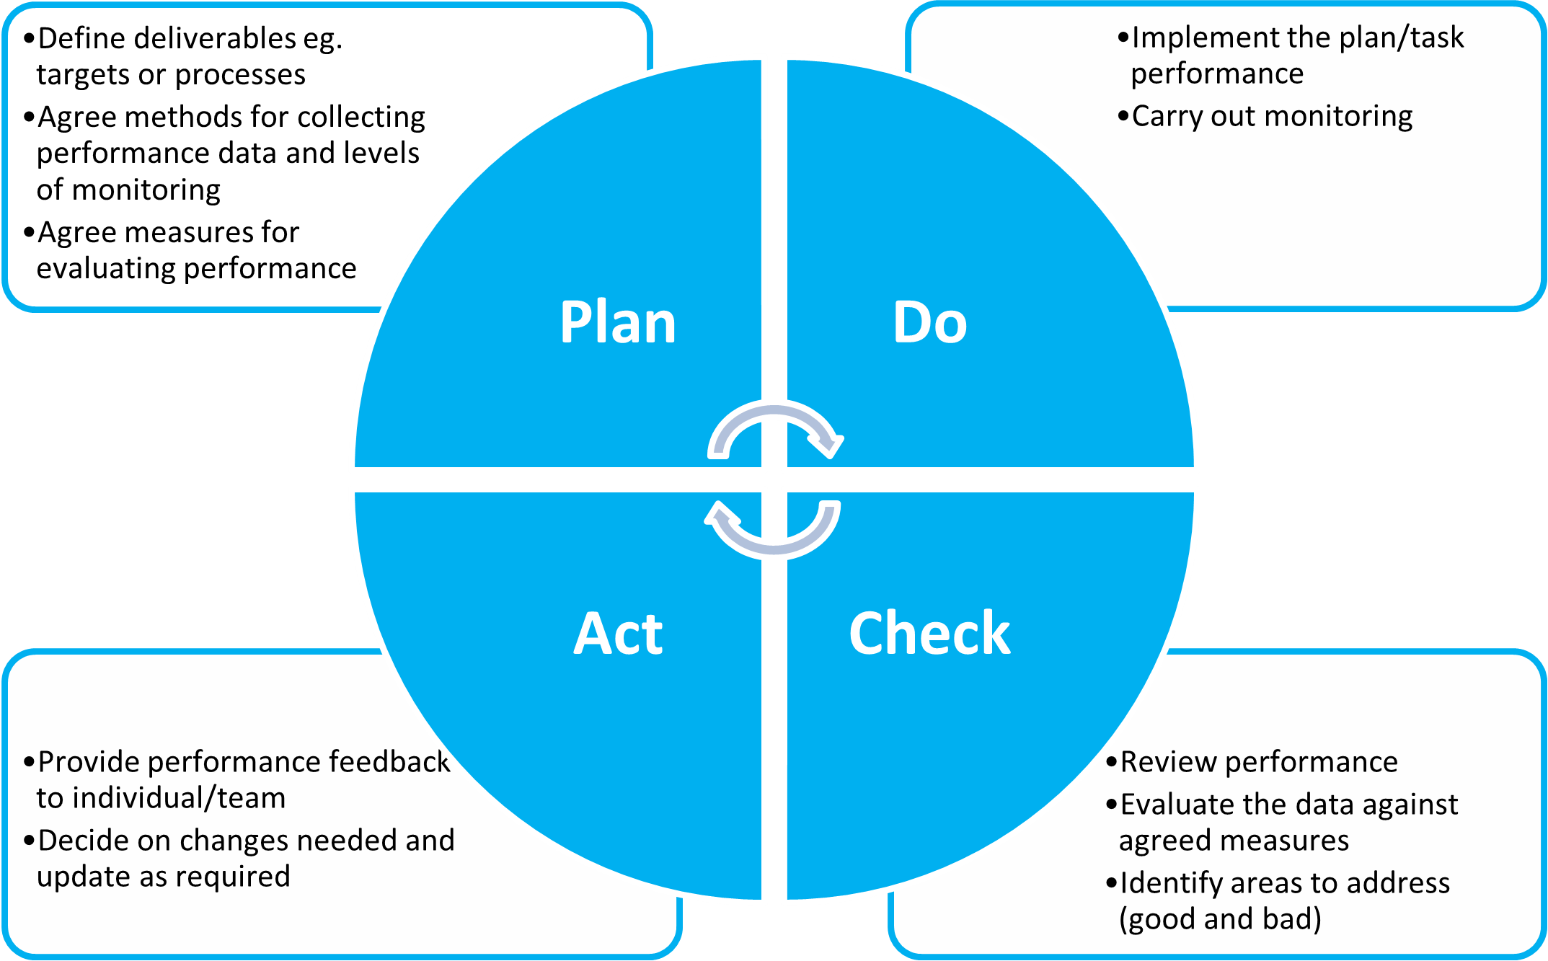

What ways do performance and behaviour problems show up?

Your notes:

- Managing People

  - Motivation

Psychologists generally refer to two types of motivation:

Extrinsic (Head)

Intrinsic (Heart)

Finding out what motivates your team can be useful when managing successful performance - both aspects can play a part in engaging employees. However, whilst extrinsic factors are important, research tells us that creating the right environment which taps into intrinsic factors tends to lead to higher levels of engagement and increased levels of discretionary effort.

  - Motivation Theory

Maslow’s Hierarchy of Needs Hertzberg’s Two Factor Theory
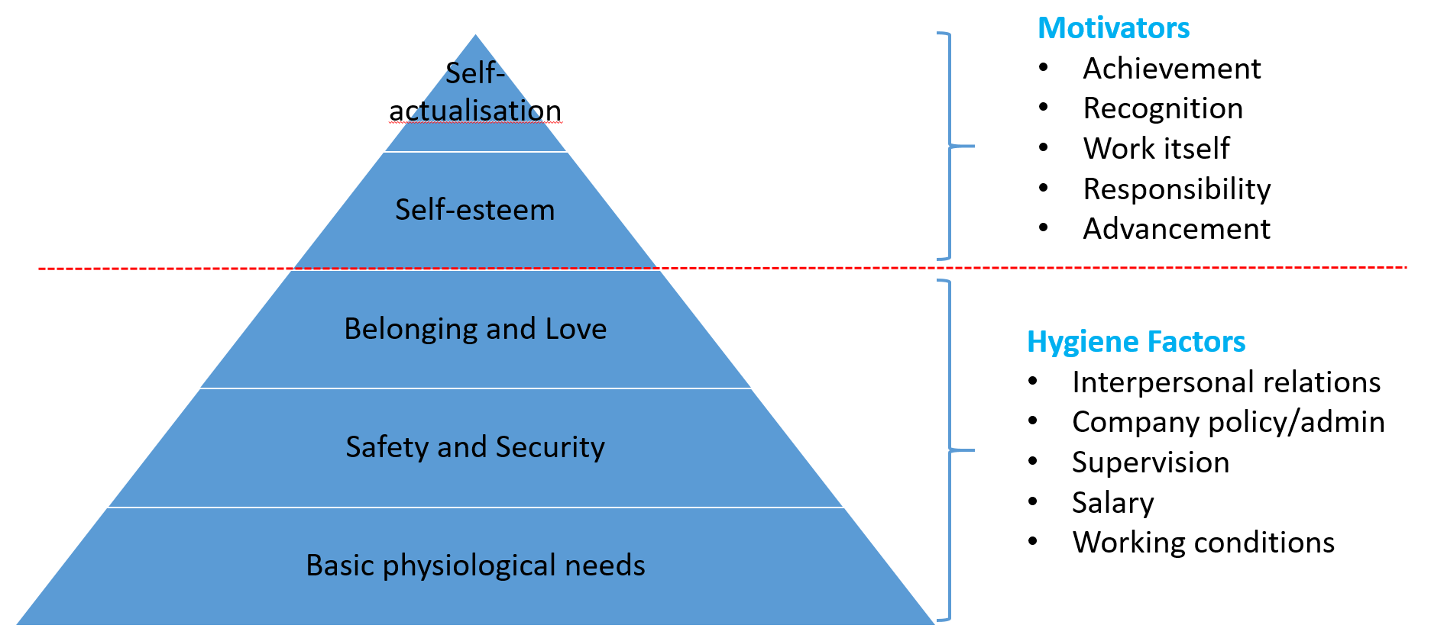

Maslow’s Hierarchy of Needs

Biological and Physiological
Safety and Security
Belonging and Love
Self-Esteem
Self-Actualisation

Herzberg's Two-Factor Theory

- Hygiene factors Characteristics associated with unhappiness at work
- Motivation factors Route to satisfaction

Practical activity:

What motivates and demotivates you?

Take a moment to consider whether you know what motivates individual members of your team. If not, how you could find out?

What signs may you see that indicate motivation or demotivation?
Motivated | Demotivated

  - Capability and Commitment

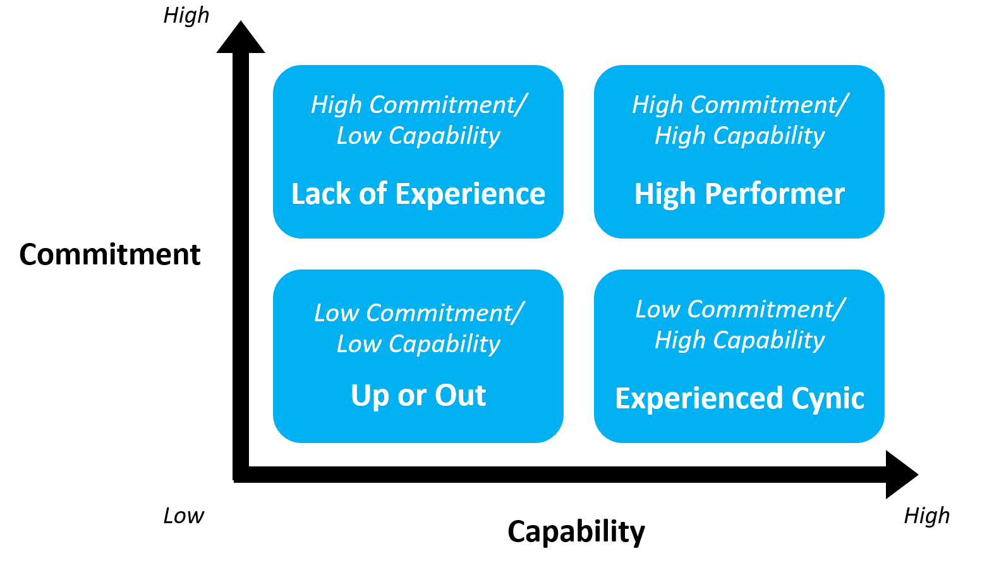
Adapted from Max Landsberg, the Tao of Coaching

The matrix above developed by Max Landsberg shows a simple way to evaluate your employees then apply the most appropriate leadership style. The model categorises employees into the four areas shown:

- Low capability/low commitment
- Low capability/high commitment
- High capability/low commitment
- High capability/high commitment

Your notes:

  - Delivering Feedback

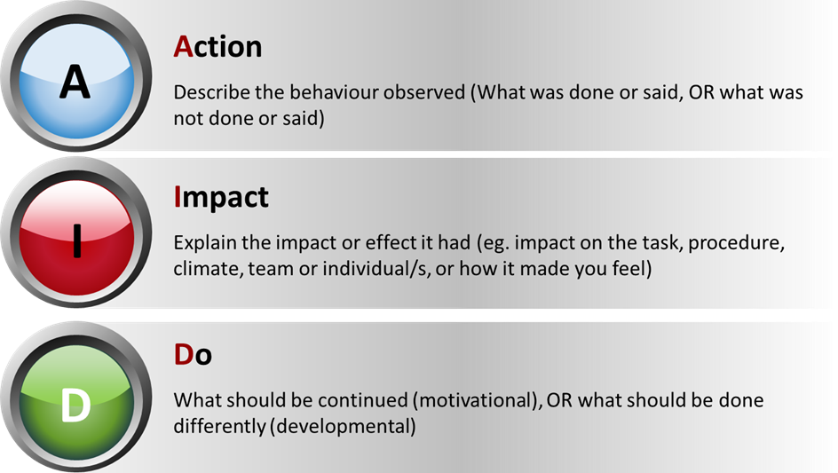

Feedback has two main purposes:

- Motivational To build confidence
- Developmental To build competence

Practical activity:

- Think of a person you need, or would like to give feedback to.
It can be a future or past scenario, as long as you have an example.
- Prepare your feedback using the AID model
- Also prepare any questions you may wish to ask
- Practice this with a trusted person - for example a colleague, your coach/mentor, your line manager, or even the individual you wish to give feedback to if you feel this is appropriate.
- Afterwards, reflect on what worked well and what you may want to do differently in the future. Capture any development points in your personal development plan.

Your notes:

