Organising Effective Teams
Delegate Workbook

Organising Effective Teams

Module Aim

On completion, you will:

- Understand the stages of team development
- Recognise the characteristics of a high performing team
- Know how to develop your team
- Be able to apply delegation principles effectively

Indicative content:

- Characteristics of a high performing team
- Tuckman’s model and the stages of team development
- Managing the team through the stages
- Team cohesion/levels of trust
- Barriers to effective team working
- Prioritisation matrix
- Rules of delegation

Module 2
Organising Effective Teams

1.0 What is a team?

Teams and Groups differ in five key ways:

Task orientation:

Purpose:

Degree of interdependence:

Degree of formal structure:

Familiarity among members:

Your notes:

2.0 High performing teams

2.1 Stages of Team Development

Tuckman’s Stages of Team Development, 1965

 | What the team is doing: | You might feel:
Forming
Storming
Norming
Performing

Your notes:

2.2 The characteristics of an effective team

A great team
A dysfunctional team

Your notes:

2.3 Insight to the 5 behaviours

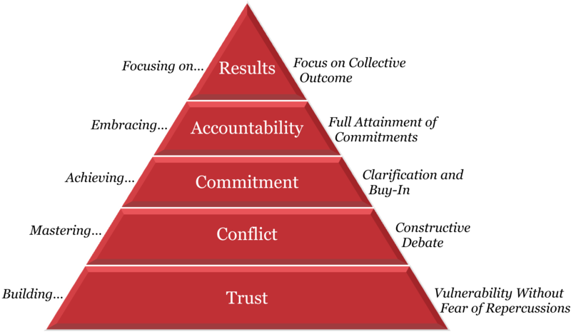

The Five Behaviours of a Cohesive Team, Patrick Lencioni

Level 1 Trust
Level 2 Conflict
Level 3 Commitment
Level 4 Accountability
Level 5 Results

3.0 Time management

3.1 Covey’s Prioritisation Matrix

When managers have a number of objectives to plan, it is essential to be able to prioritise them effectively. Resource availability may mean that only a few can be scheduled at any time. Steven Covey’s prioritisation matrix provides a simple means of assessing objectives and using resources in the most effective and efficient manner.

Covey proposes that all objectives can be viewed in terms of how important they are and how urgent they are. This breaks down into four quadrants from which we can assess our priorities.

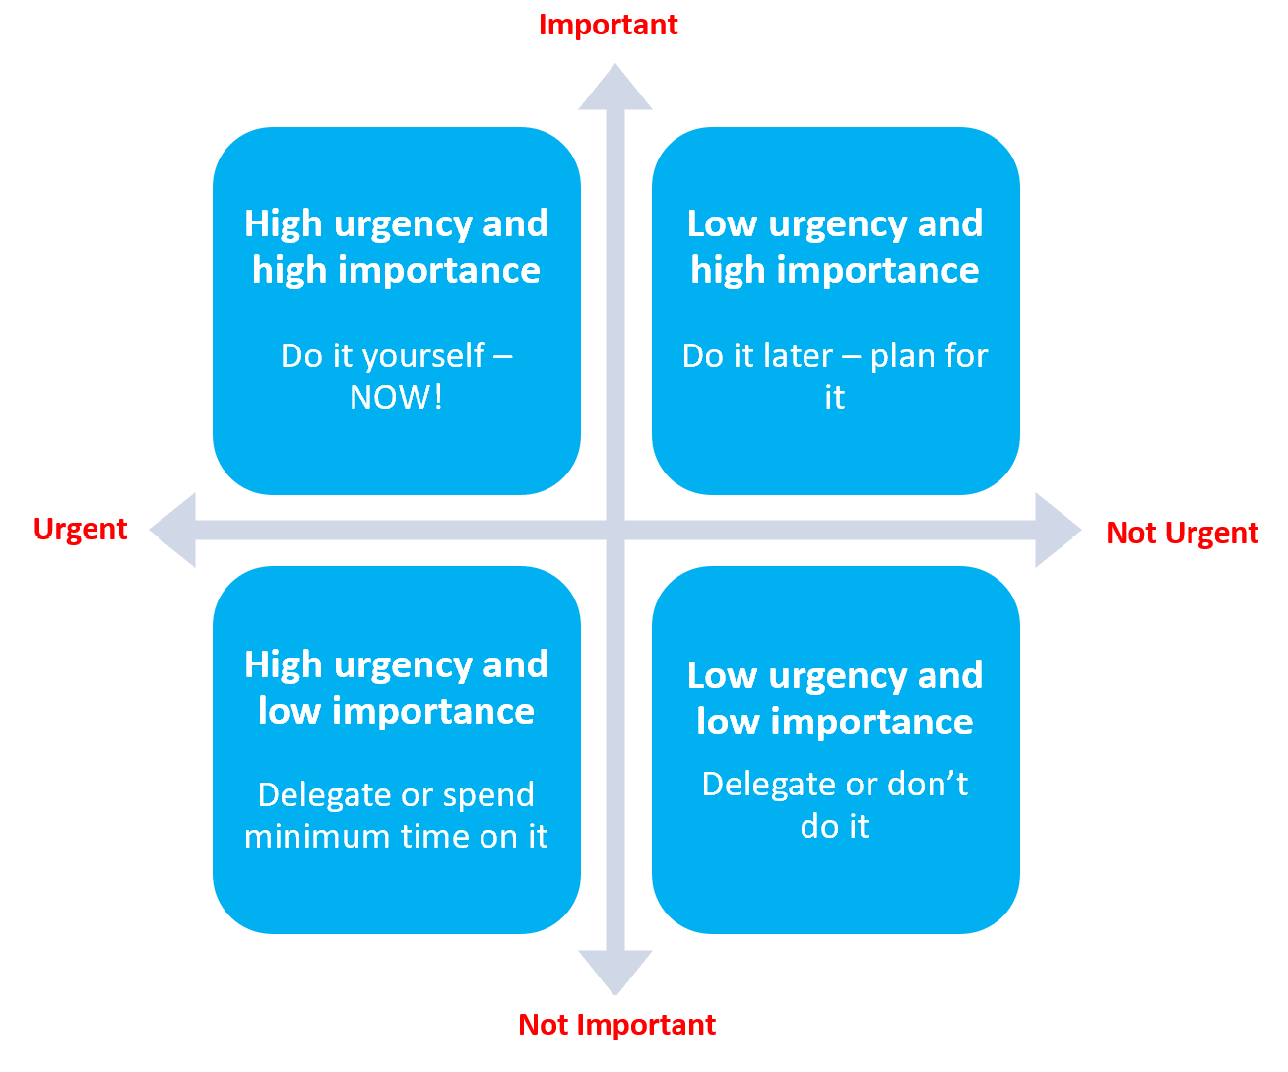

The aim is to be spending time on the top half of the quadrant, with tasks that are of high importance.
Urgent Tasks: Cause us to react, we stop what we’re currently doing and work on the urgent task instead.
Important Tasks: Lead us towards our overall mission or goals and these key actions often require planning, organisation, and initiative. Nothing else should be in the top half. This is why it is impossible to manage your time properly without goals. Another way of thinking about whether the task is important or not is to ask yourself “If I could press a button and have it done for me, would I?”

1
Urgent and
Important
2
Not Urgent but Important
3
Urgent but Not Important
4
Not Urgent and
Not Important

Your notes:

5.2 When to delegate

Delegation goes beyond asking someone to do something – there is a wide range of freedom you can offer to team members. The more experienced they are, the more you may decide to delegate and this may also determine the complexity of the task you give.

A good place to start is by deciding which tasks are most appropriate. Think also about when would be appropriate to ask staff to perform certain tasks and make decisions. The benefits of delegation can be vast, but make sure you take time to adapt any agreements between you and the individual regarding delegated tasks, responsibility and freedom, appropriately to the situation.

Capture your thoughts from the online module to help you when deciding whether delegating is appropriate:

Time
Availability
Criticality

5.3 How to delegate – the golden rules

Your notes:

