Module 1
Effective Communication
Delegate Workbook

Module 1
Effective Communication

Module Aim

- Understand the importance of effective communication
- Understand methods of communication and appropriate use
- Recognise different communication styles, their merits, and limitations
- Identify the strengths and limitations of their own communication style

Module Objectives

On completion, you will understand:

- Different communication methods and their best use
- Different communication levels
- Core communication skills
- Mehrabian/words, tone and actions
- DiSC profile/own preferences
- Communicating with different styles

“The single biggest problem in communication
is the illusion that it has taken place”
George Bernard Shaw

Module 1
Effective Communication

1.1 Different Methods of Communicating

We communicate with others using a variety of written, visual and oral methods. Capture as many different types as you can, along with the advantages and disadvantages.

Written

Methods
Advantages | Disadvantages

Visual

Methods
Advantages | Disadvantages

Oral/Verbal

Methods
Advantages | Disadvantages

Your notes:

1.2 Workplace Records

1.2.1 What records of communication do you keep in the workplace?

1.2.2 How do you ensure they are up to date?

1.2.3 Why is it important to keep accurate records of communication?

2.0 Communication Process
2.1 Levels of communication

Almost everyone has to communicate with others to get work done. In the workplace, it is not just the amount of communication, but the type of communication which is important.

Degree of personal risk involved

Exchanging
RITUAL
- Exchanging Ritual

- Giving Information

- Sharing ideas

- Making judgements

- Disclosing values

- Expressing feelings

2.2 Authentic Communication

We have just looked at the levels of communication and degree of personal risk involved. So why not take no risks and stay at the basic “exchanging ritual” or providing factual information as required?

It does have a place, and levels 1-3 on the previous diagram are very useful for simple tasks, such as if your boss asks you for some data, or to acknowledge something, or even maintain a basic level of contact. However, it can be very limited and is less effective when dealing with change or problems in the workplace. Here levels 4-6 become more effective. Think of a change project that you may have been involved with, maybe there was a degree of decision making involved. Were you asked for your input? How did you feel?

Sharing ideas, values and feelings can help to contribute to a more effective work environment. It may be that not everyone agrees, and frequently in the workplace, you will find you have people at the opposing end of the spectrum. However, allowing others to contribute, have their voice heard, and debate the options will bring greater diversity into your decision-making and ultimately lead to a greater level of buy-in than simply dictating, or rail-roading someone else’s views.

That doesn’t mean you have to share your ideas, values, and feelings every day on every topic. This would become tiring, time consuming and you may even have met people who do “over-share” at times. They let you know how they feel about everything, you may know more about their personal life than your feel comfortable knowing. Pausing to consider the objective of your communication can help you to decide whether it is a situation which just required the facts, or maybe something where your opinion and feelings may add greater perspective.

In summary, emotions naturally sometimes play a part in how we feel and communicate, and when you try to mask these, sometimes it will be evident that you are saying something, but perhaps not fully on board. It is important to be honest, although recognise that there may be times, we need to take a break to decide the best way to communicate something effectively, rather than simply shooting from the hip. As part of this programme you will learn different methods for presenting your input in a constructive manner.

Take some time to think about the following questions:

- Which level do you operate at most of your time in your workplace?
- What opportunities do you have in terms of your workplace communication?

2.3 The Communication Cycle

Successful communication starts with the acceptance of a simple principle:

“The communicator has total responsibility for getting a message across
and checking that the message has been understood”.

Communication is a process like any other, e.g. Inputs are transformed through a process to produce outputs. The process is continuous as illustrated in the diagram below:

Stage 1 -Sender

(Ideas/Thinking)

Stage 2 - Compose/Encode

(Defining the message)

Stage 3 - Transmit

(Sending the message)

Stage 4 – Receiver
(Recipient notices/hears the message)

Stage 5 – Decode
(Recipient processes the message)

Stage 6 – Feedback
(Reviewing outcomes and feedback, then taking action)

Think about any actions you need to take – for example do you always consider the right way to send the message, or simply rely on the method you prefer? Capture any notes in your action plan.

3.0 Communication Skills

Mehrabian’s Communication Theory
%

Albert Mehrabian developed this model after much research around the communication of feelings and attitudes. It usefully demonstrates the importance of factors other than words alone when trying to convey meaning (as the speaker) or interpret meaning (as the listener). It is a helpful model for thinking about all three aspects when communicating to ensure, where possible, all three are appropriately aligned.

It is important to note that Mehrabian’s research related to communications of feelings and attitudes. Consideration, therefore, needs to be given to the context of the communication, as this is not a general rule that you can transfer to any situation.

For example, when using methods such as email and telephone, this does not mean that these messages will automatically be no good because they are missing the visual element. It means greater care would need to be placed on the use of language and tonality. The inclusion of icons with facial expressions and similar within text and instant messages, further highlights the significance that non-verbal signs play in aiding effective communication.

His research is helpful in drawing attention to the importance of factors besides just language alone when trying to convey meaning (as the speaker) or interpret meaning (as the listener). When communicating it is helpful to think about all three aspects to ensure, where possible, all three are appropriately aligned.

Perhaps you can think of times when you have observed or been on the receiving end of something where this was not the case. You will usually walk away with a feeling that something was not right or didn’t feel genuine.

What are the barriers to effective communication?

4.0 Emotional Intelligence

Whats the difference?

IQ?

EQ?

“Watch your thoughts, they become your words;
Watch your words, they become your actions;
Watch your actions, they become your habits;
Watch your habits, they become your character;
Watch your character, it becomes your destiny”
Lao Tzu

4.1 Emotional Intelligence Model

Goleman’s Model

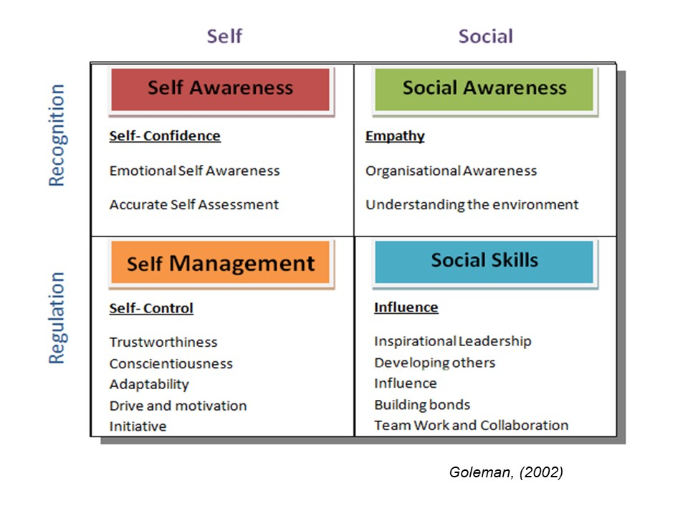
Self Awareness | Social Awareness
Self Management | Social Skills
4.2 The four quadrants of emotional intelligence

 | What I see | What I do
With myself | SELF AWARENESS  Accurate self-assessment: realistic evaluation of your strengths and weaknesses  Emotional self-awareness: the ability to understand your emotions and recognise their impact on work performance and relationships  Self-confidence: strong and positive sense of self-worth based on accurate self-assessment | SELF MANAGEMENT  Self-control: ability to keep disruptive emotions and impulses under control  Trustworthiness and Conscientiousness: consistent display of honesty and integrity, words match actions, follow through on commitments  Adaptability: skill at adjusting to changing situations and overcoming obstacles  Initiative and Drive for Achievement: maintain high personal standards of excellence, seize opportunities
With others | SOCIAL AWARENESS  Empathy: skill at sensing others’ emotions, understanding their perspectives, and taking an active interest in their concerns  Organizational awareness: the ability to read the dynamics of groups, build personal networks, and navigate politics | SOCIAL SKILLS  Influence: wielding effective tactics for persuasion  Conflict Resolution: negotiating and resolving disagreement  Develop others: bringing out the best in others through coaching and feedback  Communication: listening openly and sending convincing messages  Teamwork: creating group synergy in pursuing collective goals

4.3 Developing your EQ

Here are some brief tips of how to increase your EQ:

Self Awareness

- Watch how you feel. Look for patterns of when you have strong emotions, which get in the way of clear thinking
- Monitor how you feel in different situations; and make note of your emotional triggers
- Track how you react when your emotions are running high.

Self Management

- Use your emotions constructively
- Buy time before acting (e.g., take a break, go for a walk, write your emotions down into a letter or an email without an address… then revisit it later)
- Anticipate emotionally charged situations

Social Awareness

- Play the observer and watch how a meeting unfolds
- Check your observations with others who were in the meeting – adjust your conclusions as necessary
- Try to identify what others are feeling in different situations

Social Skills (Relationship Management)

- Help others work through their emotional responses
- Practise effective listening skills
- Don’t push other people’s buttons

4.4 Workshop Activity:

You will be given instructions on how to complete this during your forthcoming Zoom workshop, so please leave blank for now.

 | What I see | What I do
With myself | SELF AWARENESS | SELF MANAGEMENT
With others | SOCIAL AWARENESS | SOCIAL SKILLS

5.0 Understanding your DiSC Workplace Style

Where do you think you are?

Active, fast paced
(Assertive, louder speech, dynamic, bold)
Or

Moderate paced, thoughtful
(Calm, methodical, careful, softer speech)

Accepting
(People-focused, empathising, receptive, agreeable)
Questioning
(logic-focused, objective, sceptical, challenging)

Combine the two:

What are the key strengths of your style?

What are the limitations of your style?

5.1 DiSC Workplace

5.1.1 DiSC Workplace Model

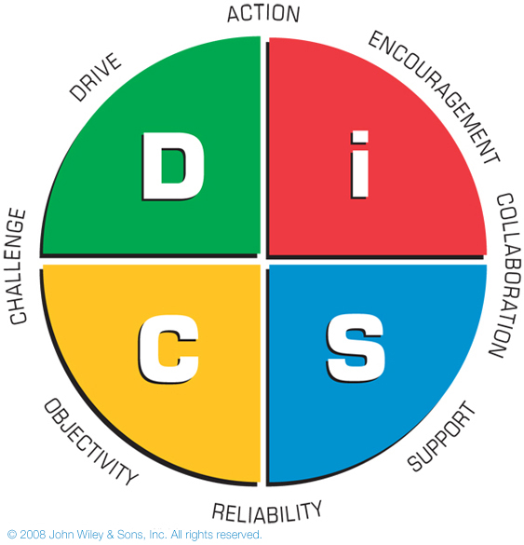

Key Points:
- 1928 William Moulton Marston was the first psychologist to study “normal people” and “normal behaviour”
- 1940 the first DiSC assessment (paper based) was developed
- DiSC measures tendencies and priorities, not skills or ability
- The DiSC model shows four basic behavioural styles that describe how people approach their work and relationships.
- The tool can be used to help you understand your own and other’s workplace behaviours, helping you to connect better with others.
- There are no good or bad styles – all four have strengths and limitations. People are a blend of all four but generally

5.1.2 DiSC Workplace Styles

Dominance  Direct  Results-orientated  Firm  Strong-willed  Forceful | Influence  Outgoing  Enthusiastic  Optimistic  High-spirited  Lively
Conscientiousness  Analytical  Reserved  Precise  Private  Systematic | Steadiness  Even-tempered  Accommodating  Patient  Humble  Tactful

Your notes:

