Module 5
Critical Thinking
Delegate Workbook

Module 5
Critical Thinking

Module Objectives

On completion, you will understand:

- The difference between critical and non-critical thinking
- Your personal critical thinking style
- How to develop critical thinking skills and strategies
- How to apply the standards of critical thinking to make clear and reasoned judgements
- How to use a critical thinking process to build and analyse arguments

Topics covered:

- Characteristics and behaviours of critical thinkers
- Critical thinking styles
- The whole brain thinking model
- The 9 standards for quality thinking
- The 8 elements of thought
- Ego-centric and socio-centric thinking

Module 5
Critical Thinking

- What is Critical thinking

1.1 What is critical thinking?

Watch the video and make your own notes on the key points

1.2 Definitions of-critical thinking

Critical thinking
Non-critical thinking

2.0 The Characteristics of Critical Thinking

2.1 Critical thinking and unconscious bias

Which of these unconscious biases are you now more consciously aware of for yourself at work?

Please bring your personal experiences and examples of this to the module for further discussion.

2.2 The Whole Brain Thinking Model

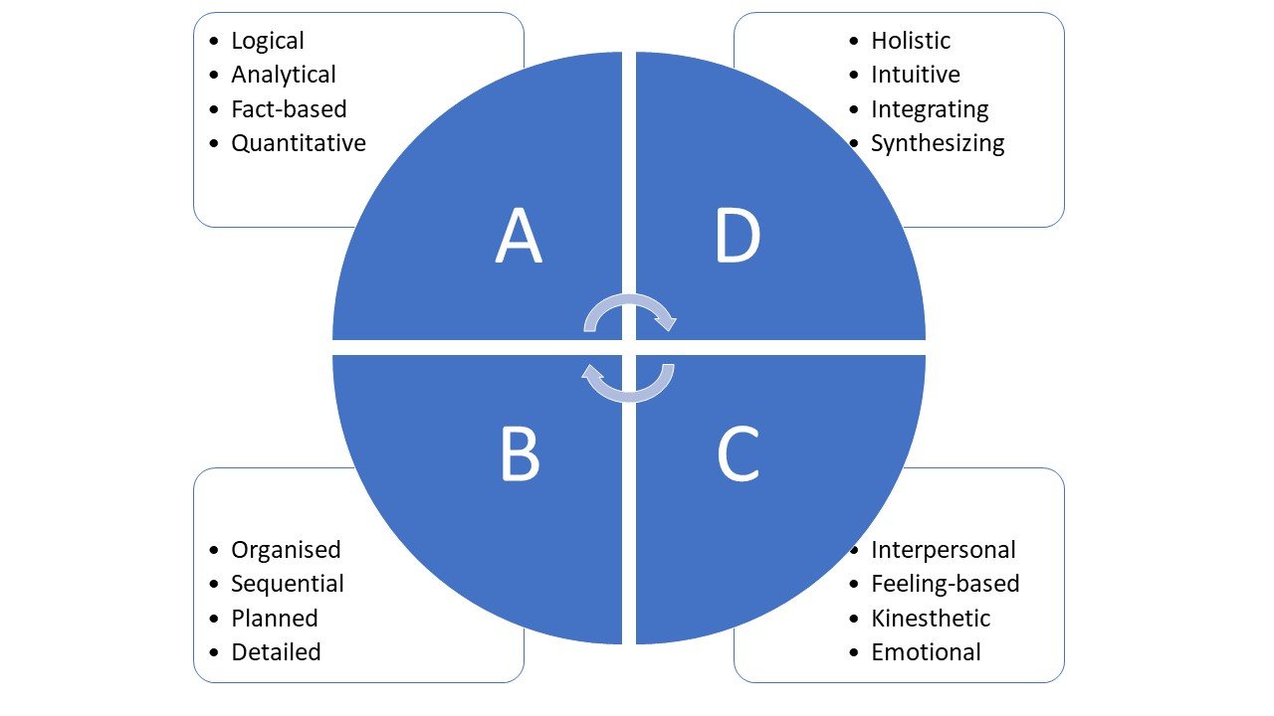

A
B
C
D

Questions to consider and bring to module:

- Which of the above areas are preferences and more natural for you when thinking?
- Which of them would be beneficial for you to consider developing?

3.0 Models for Critical Thinking

3.1 The 8 elements of thought

Purpose
Questions
Information
Inferences
Concepts
Assumptions
Implications
Points of view
Taken from the Paul-Elder framework for critical thinking

3.2 The 9 standards for quality thinking

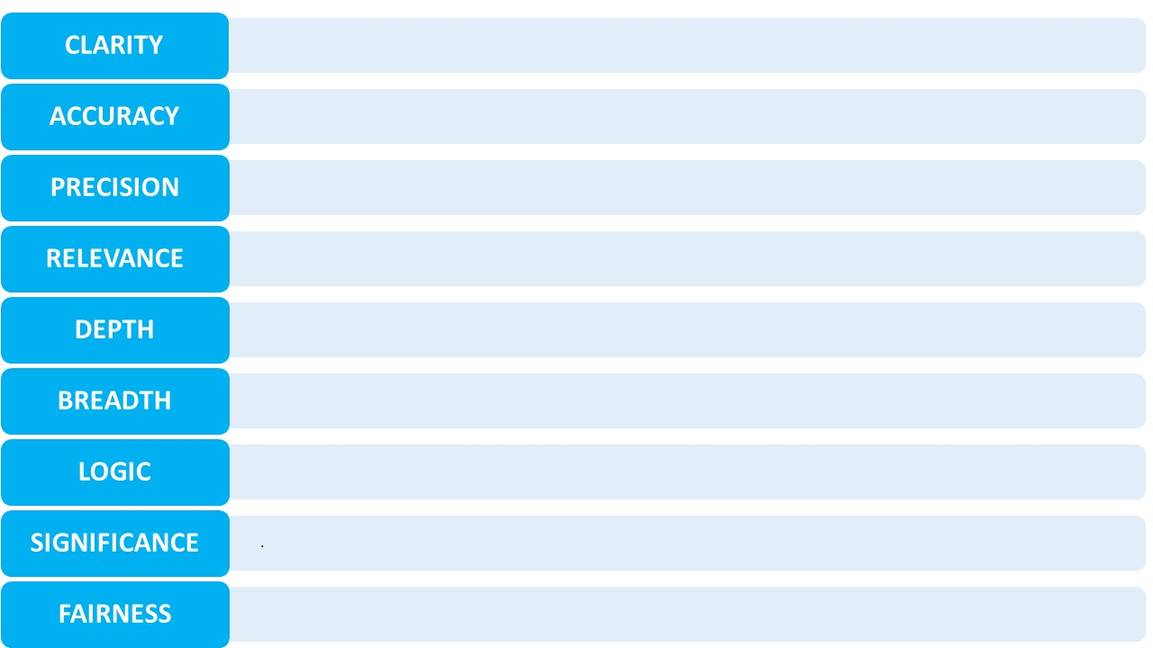

3.3 Ego-centric and socio-centric thinking

Ego-centric

Socio-centric

