Module 2
Inspiring Leadership
Delegate Workbook

Module 2
Inspiring Leadership

Module Aim

- Articulate the difference between management and leadership
- Understand a range of leadership styles and their best use
- Identify your own leadership style
- Recognise the difference between pressure and stress
- Know how to manage own stress

Module Objectives

On completion, you will understand:

- Growth mindset
- Difference between management and leadership
- The range of leadership styles and leadership continuum
- Own strengths and limitations
- Signs of stress
- Techniques for managing stress

Module 2
Inspiring Leadership

1.1 Growth Mindset

Challenges
Obstacles
Effort
Criticism
Success of others

Your notes:

Consider the following and capture your responses:

How do you feel about the concepts of:

Failure?

Learning?

Now and yet?

What kind of environment do you create at work?

What kind of mindset is encouraged by your employers?

What are your challenges in developing a growth mindset about yourself?

What are your challenges in developing a growth mindset about your team?

2.0 Leadership Theories

Are leaders born or made?

For many years leadership has been the subject of much debate. There are a number of theories available to explain the concept and practice. Some of the main ones are described below:

Trait | Behaviour | Situational/ Contingency | Power and Influence

Your notes:

2.1 Power and Authority

Leadership
Power
Authority

Your notes:

2.2 Bases of Power

Personal power Something linked to the leader’s personality, competence and integrity; or

Positional power Power given to a leader by the organisation or as a result of a position they hold.

Personal Power

Expert
Referent
Positional Power
Legitimate
Reward
Coercive

This theory later saw the addition of two further styles shown below. Overall, it is thought that using personal power is the more effective alternative.

Information Access to – or possession of – useful information.
Connection Association of the leader with influential persons or organisations.

Your notes:

2.3 Informal Sources of Power

In addition to Raven’s seven power bases, there are a number of alternative sources of power that the leader needs to be aware of in order to maximise leadership potential. Four informal sources of power in organisations can be identified as follows:

Personal Ethics

Organisational Culture

Organisational Systems

Stakeholders

Your notes:

Reflect and consider the 5 areas above in the context of your current role. What do you do that would demonstrate these areas? You may also want to capture ideas of things you would like to do in the future.

Showing respect for others

Serving others

Showing justice

Manifesting honesty

Building a sense of community

2.4 Leadership Styles

Tannenbaum and Schmidt, 1958

Use of authority by manager
 |  |  | Area of freedom for subordinates
Makes decision and announces it | “Sells” decision | Presents ideas then invites questions | Presents tentative decision subject to change | Presents the problem, gets ideas then makes decision | Defines limits and lets group make decision | Allows subordinate to function within defined limits
Tells | Sells | Consults |  |  | Joins

Thinking about this continuum, consider the following points:

- What skills would a manager be using at the “tell” end of the continuum?
- What skills would a manager be using at the “ask” end of the continuum?
- Where do you currently spend most of your time

Your notes:

2.5 Transactional v Transformational Leadership

We all tend to have a natural preference for one style or the other when leading a team. As you have read from the leadership continuum it is not the case that one style better than the other. It is useful to be able to accurately assess your own preference so you can then focus on how to maximise that style and also develop your capacity in your least favoured area.

“Setting an example is not the main means of influencing another, it is the only means”
Albert Einstein

2.5.1 Transactional Leadership (often known as traditional “Management”)

A transactional management style is more concerned with maintaining the normal flow of operations. They can be described as “keeping the ship afloat.” and provide stability through refreshing, reinforcing, and refining existing practices. Transactional leaders use disciplinary power and an array of incentives to motivate employees to perform at their best. The term “transactional” refers to the fact that this type of manager essentially motivates subordinates by exchanging rewards for performance. They are interested in the implementation and enjoy the status quo.

Being transactional means that the manager generally does not look ahead in strategically guiding an organization to a position of market leadership; instead, these managers are solely concerned with making sure everything flows smoothly today. They focus on the day to day progress towards goals.

Your notes:

2.5.2 Transformational Leadership

A transformational leader goes beyond managing day-to-day operations and crafts strategies for taking the department or work team to the next level of performance and success. Transformational leadership styles focus on team-building, motivation and collaboration with employees to accomplish change for the better. Transformational leaders set goals and incentives to push their subordinates to higher performance levels, while providing opportunities for personal and professional growth for each employee.

Transformational leaders are inspirational and tend to be charismatic, inspiring trust, admiration, and loyalty, and acting as a role model. They challenge their staff to take ownership of their work, delegate and maximise potential through understanding the strengths and weaknesses of team members. They are looking to optimise performance, challenge the status quo, and embrace and create change.

Take some time to think about your own style as follows:

- Where do you believe your preferences lie?

Your notes:

3.0 Management or leadership?

Management | Leadership

Your notes:

Think about a leader you most admire – that can be anyone famous or not, past or present. Consider what it is that made you select them - see if you can identify some key characteristics, for example:
- What do they do/say?
- How do they behave?

Focus on a couple of the characteristics you have identified.

- What makes that characteristic useful?
- What do you think may happen if you over-use it?

3.2 Responsibility and accountability

What is the difference between responsibility and accountability?

How do you define limits of authority?

What are your limits of authority?

What are your levels of accountability?

3.3 What it means to be a leader

Considering everything you have heard about leadership so far and what you know about yourself, perhaps using some insights from your DiSC profile, answer the following questions:

What do you recognise as your strengths in leadership and management?

What is your stretch to develop?

What difference would that make at work?

4.0 Stress

What is stress?

The Health and Safety Executive (HSE) defines stress as:

“the adverse reaction people have to excessive pressures or other types of demand placed on them”.

There is often much misperception between the terms pressure and stress. Commonly confused with stress, pressure is what most people mean when they say they are stressed.

In reality, a certain amount of positive pressure or stress is necessary and healthy and gives us the motivation and drive to perform. In some cases, it can even improve performance, for example when faced with a deadline. However, extreme and prolonged pressure can lead to stress if it exceeds coping capacity, which can be a real risk to our health.

Review the results of the online questionnaire and consider the following:

What causes my stress? What are the triggers?:

What impact does it have?:

4.1 Signs of Stress

The following extract is taken from CIPD’s factsheet “Stress in the Workplace”.
The first signs that indicate employees may be suffering from excessive pressure or stress are changes in behaviour or performance. The kinds of change that may occur are listed below:

Work performance
- declining/inconsistent performance
- uncharacteristic errors
- loss of control over work
- loss of motivation/commitment
- indecision
- lapses in memory
- increased time at work
- lack of holiday planning/usage

Regression
- crying
- arguments
- undue sensitivity
- irritability/moodiness
- over-reaction to problems
- personality clashes
- sulking
- immature behaviour

Withdrawal
- arriving late to work
- leaving early
- extended lunches
- absenteeism
- resigned attitude
- reduced social contact
- elusiveness/evasiveness

Aggressive behaviour
- malicious gossip
- criticism of others
- vandalism
- shouting
- bullying or harassment
- poor employee relations
- temper outbursts

Other behaviours
- out-of-character behaviour
- difficulty relaxing
- increased consumption of alcohol
- increased smoking
- lack of interest in appearance/hygiene
- accidents at home or work
- reckless driving
- unnecessary risk-taking

Physical signs
- nervous stumbling speech
- sweating
- tiredness/lethargy
- upset stomach/flatulence
- tension headaches
- hand tremor
- rapid weight gain or loss
- constantly feeling cold
Any other signs we see at work?:

4.2 Four Types of Stress

Dr Karl Albrecht, 1979 “Stress and the Manager.” identified four different types of stress:

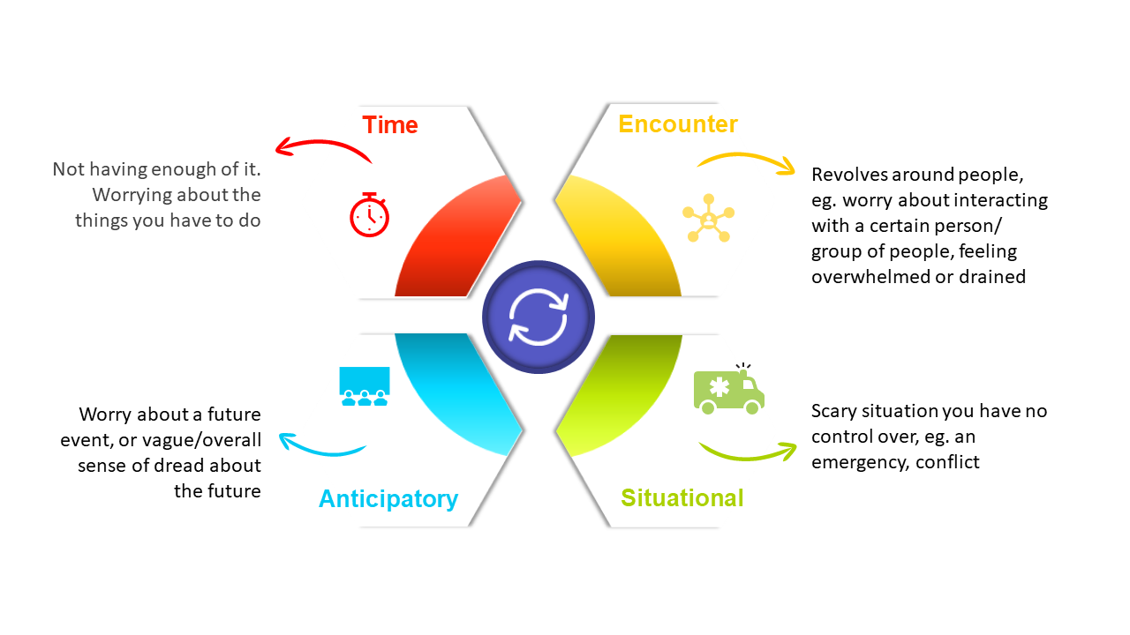
Record your main type of stress:

Record any actions you can take to reduce this:

4.3 Managing Stress

As a line Manager you have a pivotal role in organisational stress management. These generally fall into three principal areas:

Own behaviour
Employee Behaviour/ Duty of Care
Legal Responsibilities

Your notes:

4.4 Techniques for Managing Stress

There are various ways of managing stress and what works for one person may not necessarily work for another. The first step to managing stress is identifying the cause. You could address this by:

Keep a well-being diary
Recording stressful activity is an effective way of finding out both what triggers stress for you and what level of stress you prefer. To use, you should make a note of your stress levels and how you feel throughout the day. For example:

At a regular intervals, for example every hour, record routine stress. Note down:
- The time
- The amount of stress that you feel (on a scale of 1 to 10)
- How happy you feel
- Whether you are enjoying your work
- How efficiently you are working

When stressful events occur, write down:
- What the event was
- When and where it occurred
- What important factors made the event stressful?
- How stressful the event was?
- How you handled the event
- Whether you tackled the cause or the symptom
- Whether you feel you dealt with the stress correctly

Remember to tell yourself the truth – to be useful this needs to be an accurate reflection of your experiences. After a few weeks you should be able to analyse this information. It may be interesting as you carry out your analysis to note down the outcomes of the jobs you were doing when you felt under stress.

This should give you two types of information:
- An understanding of the level of stress you are happiest with and the level of stress at which you work most effectively. You may find that your performance is good, even when you feel upset by stress.

- An insight to the main sources of unpleasant stress in your life, including what circumstances make the stresses particularly unpleasant. This should help you to begin to understand whether your strategies for handling these are effective.

“The keys to good stress management are building emotional strength, being in control of your situation, having a good social network and adopting a positive outlook” Professor Gary Cooper

Additional Techniques

Your notes:

