Effective Communication
Delegate Workbook

Effective Communication

Module Aim

- Understand the importance of effective communication
- Understand methods of communication and their appropriate use
- Be aware of the communication process
- Recognise communication skills
- Recognise different communication styles, their merits, and limitations

Module Objectives

On completion, you will understand:

- Different communication methods and their best use
- Different communication levels
- Core communication skills
- Mehrabian/the importance of congruence between words and actions
- DiSC profile/own preferences
- How to communicate best with different styles

“The single biggest problem in communication
is the illusion that it has taken place”
George Bernard Shaw

Effective Communication

1.1 Different Methods of Communicating

We communicate with others using a variety of written, visual and oral methods. Capture as many different types as you can, along with the advantages and disadvantages.

Written

Methods
Advantages | Disadvantages

Visual

Methods
Advantages | Disadvantages

Oral/Verbal

Methods
Advantages | Disadvantages

Your notes:

1.2 Workplace Records

1.2.1 What records of communication do you keep in the workplace?

1.2.2 How do you ensure they are up to date?

1.2.3 Why is it important to keep accurate records of communication?

2.0 Communication Process
2.1 Levels of communication

Almost everyone must communicate with others to get work done. In the workplace, it is not just the amount of communication, but the type of communication which is important.

Degree of personal risk involved

Exchanging
RITUAL
- Exchanging Ritual

- Giving Information

- Sharing ideas

- Making judgements

- Disclosing values

- Expressing feelings

2.2 Authentic Communication

We looked at the levels of communication and degree of personal risk involved. So why not avoid all risks and stay at the basic “exchanging ritual” or providing factual information as required?

Your notes:

Take some time to think about the following questions:

Which level do you operate at most of your time in your workplace?

What opportunities do you have in terms of your workplace communication?

2.3 The Communication Cycle

Successful communication starts with the acceptance of a simple principle:

“The communicator has total responsibility for getting a message across
and checking that the message has been understood”.

Communication is a process like any other, e.g. Inputs are transformed through a process to produce outputs. The process is continuous as illustrated in the diagram below:

Stage 1 -Sender

(Ideas/Thinking)

Stage 2 - Compose/Encode

(Defining the message)

Stage 3 - Transmit

(Sending the message)

Stage 4 – Receiver
(Recipient notices/hears the message)

Stage 5 – Decode
(Recipient processes the message)

Stage 6 – Feedback
(Reviewing outcomes and feedback, then taking action)

Think about any actions you need to take – for example do you always consider the right way to send the message, or simply rely on the method you prefer? Capture any notes in your action plan.

Your notes:

3.0 Communication Skills
Mehrabian’s Communication Theory
%

Albert Mehrabian developed this model after much research around the communication of feelings and attitudes. It usefully demonstrates the importance of factors other than words alone when trying to convey meaning (as the speaker) or interpret meaning (as the listener). It is a helpful model for thinking about all three aspects when communicating to ensure, where possible, all three are appropriately aligned.

It is important to note that Mehrabian’s research related to communications of feelings and attitudes. Consideration, therefore, needs to be given to the context of the communication, as this is not a general rule that you can transfer to any situation.

For example, when using methods such as email and telephone, this does not mean that these messages will automatically be no good because they are missing the visual element. It means greater care would need to be placed on the use of language and tonality. The inclusion of icons with facial expressions and similar within text and instant messages, further highlights the significance that non-verbal signs play in aiding effective communication.

His research is helpful in drawing attention to the importance of factors besides just language alone when trying to convey meaning (as the speaker) or interpret meaning (as the listener). When communicating it is helpful to think about all three aspects to ensure, where possible, all three are appropriately aligned.

Perhaps you can think of times when you have observed or been on the receiving end of something where this was not the case. You will usually walk away with a feeling that something was not right or didn’t feel genuine.

What are the barriers to effective communication?

4.0 Understanding your DiSC Workplace Style

Where do you think you are?

Active, fast paced
(Assertive, louder speech, dynamic, bold)
Or

Moderate paced, thoughtful
(Calm, methodical, careful, softer speech)

Accepting
(People-focused, empathising, receptive, agreeable)
Questioning
(logic-focused, objective, sceptical, challenging)

Combine the two:

What are the key strengths of your style?

What are the limitations of your style?

4.1 DiSC Workplace

4.1.1 DiSC Workplace Model

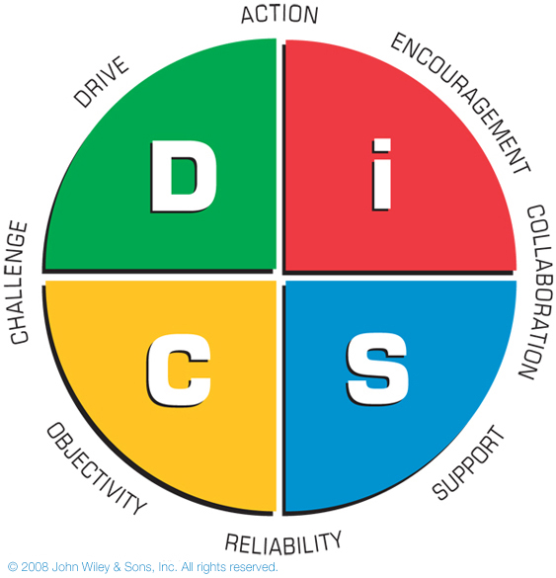

Key Points:
- 1928 William Moulton Marston was the first psychologist to study “normal people” and “normal behaviour”
- 1940 the first DiSC assessment (paper based) was developed
- DiSC measures tendencies and priorities, not skills or ability
- The DiSC model shows four basic behavioural styles that describe how people approach their work and relationships.
- The tool can be used to help you understand your own and other’s workplace behaviours, helping you to connect better with others.
- There are no good or bad styles – all four have strengths and limitations. People are a blend of all four but generally

4.1.2 DiSC Workplace Styles

Dominance  Direct  Results-orientated  Firm  Strong-willed  Forceful | Influence  Outgoing  Enthusiastic  Optimistic  High-spirited  Lively
Conscientiousness  Analytical  Reserved  Precise  Private  Systematic | Steadiness  Even-tempered  Accommodating  Patient  Humble  Tactful

Your notes:

